I found a flouting of Grice’s Maxim of Relevance on my own twitter feed. @pattymo said “I like when the boxers hug.” He was referencing a hug between boxer Floyd Mayweather and UFC fighter Conor McGregor on the night when they fought each other; the context was very clear. @DanMentos (the tweeter that I follow) replied “buddy you should try briefs”. The maxim of relevance is flouted in that briefs have nothing to do with people who box, but has very much to do with “boxers” as underwear. Boxers (underwear) tend to “hug” men’s legs less easily than do briefs, and so Dan Mentos recommends trying briefs for the extra huggage.

@DanMentos’s tweets often have this type of humor: he seems to either misunderstand something in a funny way, or says a one-liner with self-deprecating or awkward humor. He knew exactly what he was doing when he replied to @pattymo. Dan is trying to convey silliness by providing a seemingly off-topic response that, in reality, is wittily correct (based on certain meanings of lexically ambiguous words).

Mr. Mentos’s twitter followers understand his humor, though not everyone does. An outside observer might think that he is naïve, or that he is dumb, but more likely is that they think that he is joking around and trying to get a laugh. This is because of the unspoken dissonance in lexical semantics of the word “boxers” and their action of a “hug.” @pattymo likely got a good laugh out of Dan’s reply, though the conversation (if it were in person) would probably have gotten a bit more awkward (partially because @pattymo might’ve had to explain what he was saying, breaking from thought communication to definition discussion). Thankfully, for the self-esteem of @DanMentos, there is not likely to be any long-term effects from this initially outwardly irrelevant remark, even from @pattymo himself.

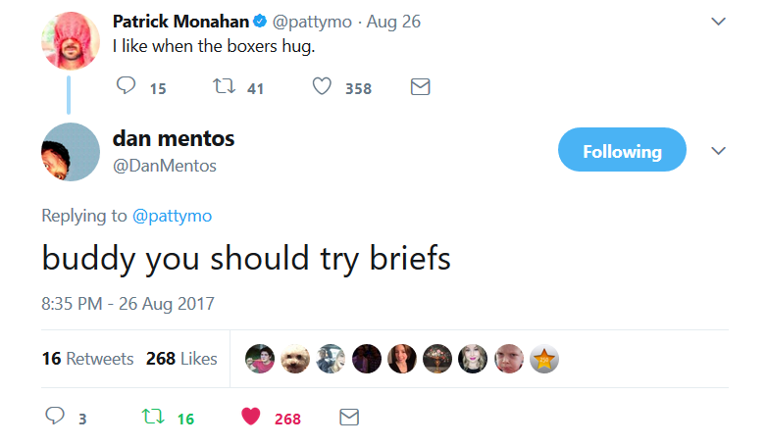<https://twitter.com/DanMentos/status/901649320964849664>